

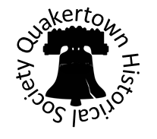

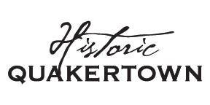

**February 2020**

**Events**

A big thank you to our luminary bag helpers Peter & Victoria Blackmore, Julie Lukens, John Harper, Jim Lukens, Jan Hench, Barbara Beck, Jack Schick, Bob & Carol Roth, and to the entire community who participated in putting out luminaries on Christmas Eve, the town looked wonderful, and it brought back many memories! In the Spring we are looking to do an Antique Appraisal Fair, along with a few other ideas we have up our sleeves.

**Membership**

At this time there are no membership dues for your QHS; we rely on the contributions from our supportive members and from the community at large. Please consider making a donation to your Quakertown Historical Society so that we may continue to serve you and the community with historical information.

**Membership Meeting**

On November 14th for our membership meeting we had a presentation by Pennsylvania Historical Recovery Services. Everyone got the chance to see some really nice artifacts that were recovered locally, and heard about some great local history.

**Update on Archives Activity**

The Society’s project to completely identify, itemize, properly store and digitally record, in a method that facilitates research, our inventory of artifacts and documents is about half done—the identifying and itemizing, anyway. We meet at the Burgess Foulke House Museum on Main Street the second Wednesday (9am-noon) and the third Thursday (6pm to 9pm) of every month. Several board members, a few members and several ‘helpers’ not associated with the QHS have participated in these work sessions. All members and other interested parties are welcome to join us.

Some results of these efforts have been: an Historical Preservation student from Allentown has satisfied his ‘field work’ course requirement, a ton of stuff that was unassociated with Quakertown has been purged and transferred to the appropriate historical society (Milford, Haycock, etc.), and many related items and documents that were stored separately have been consolidated. Items that have been evaluated and seem to have no connection to Quakertown have been separated and are being considered for sale. Board members have produced short articles on several of the finds and have been recorded as part of the archives. The restoration of several items is being done.

The Society encourages members to participate in these efforts and other activities that are planned in the coming year.

**Make a Donation**

Your Quakertown Historical Society is a 501(c)3 non-profit organization with an all-volunteer staff. Your donation will directly support your Quakertown Historical Society. Additionally, your donation may be tax deductible. You can also make a donation through our webpage (via PayPal) or check made out to: Quakertown Historical Society.

26 N. Main St. P.O. Box 846

Quakertown, PA 18951

www.QuakertownHistoricalSociety.org

QuakertownHistoricalSociety@gmail.com

Phone: 267-227-3864

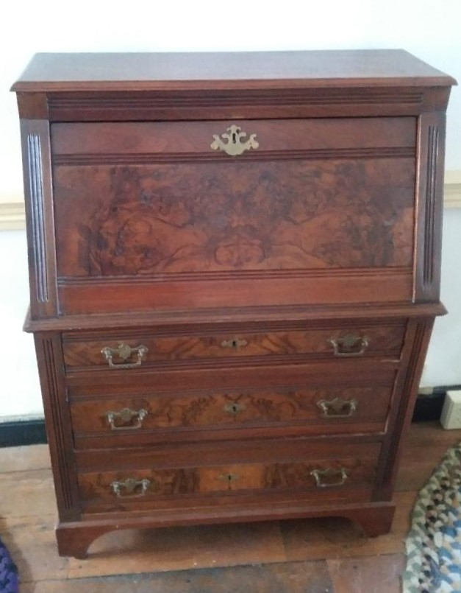

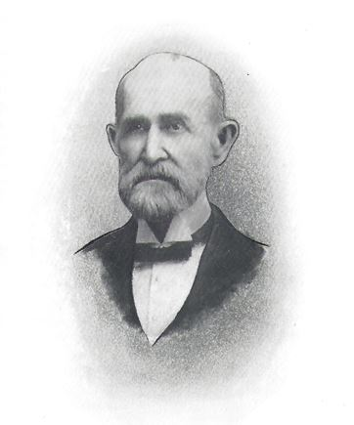

**Dr. Joseph G. Thomas Secretary Desk Donation**

Recently the Quakertown Historical Society received a gift from Frank K. Benner – a drop lid desk that once belonged to Dr. Joseph G. Thomas. Please read the biography of Dr. Thomas that appeared in the Quakertown National Bank 75th Anniversary Report in 1952.

Dr. Joseph G. Thomas, born June 15, 1829, in New Britain Township, Bucks County, Pennsylvania, was the son of Elias and Sarah (Snyder) Thomas. He was raised on a farm and received a good education, but at the age of seventeen he left home and began teaching school, which vocation he followed for eight years. In 1854 he enrolled in the Medical School of the University of Pennsylvania, graduating in 1856. After receiving his degree in medicine, he located in Applesbachsville, Haycock Township, and Bucks County and engaged in the practice of his profession. On April 3, 1860, he married Sarah Ott, daughter of Samuel and Eliza (Fluck) Ott. They had one son, Byron, who, for many years served as a teller in The Quakertown National Bank.

At the outbreak of the Civil War in 1861, he organized a company, of which he was commissioned Captain, and assigned to the Pennsylvania Reserve Corps. In the fall of 1862 he was appointed surgeon of the 118th Corn Exchange Regiment, Pennsylvania Volunteers, and subsequently became surgeon-in-chief of the Field Hospital, which position he held until the end of the war, when he returned to his home and resumed private practice. While living in Applesbachsville, he occupied the brick dwelling and office which is still standing and was later used by Dr. Milton H. Herbine and more recently by Mr. Paul Wirebach. In 1866 he was appointed assessor of Internal Revenue, and he moved to Quakertown, where he resided until his death. The home, in which he lived, was a single brick dwelling, now known as 1215 and 1217 West Broad Street having since been converted into a double house.

An item recorded in “Battle’s History of Bucks County” states that Dr. I. S. Moyer located in Quakertown on April 5, 1869, having purchased the medical practice of Doctors Joseph G. Thomas and R. J. Linderman, so it would seem that after moving to Quakertown Dr. Thomas became associated with Dr. Linderman in the practice of his profession. Dr. Thomas was one of the incorporators of the Quakertown Savings Bank and served as its cashier until it was superseded by The Quakertown National Bank, which he and his associates had organized in 1877. He was elected president of our bank at the time of its organization and continued in that office until his death. When the Quakertown Trust Company was established in 1904, Dr. Thomas, who had been one of its most active promoters, was elected as a director, and he also served there until his death terminated his career.

Dr. Thomas was undoubtedly one of the most prominent men of his time and was identified with so many activities that it is impossible to mention more than a few of them. He held various local offices from time to time, served his political party as delegate to state and national conventions and, in 1878, was elected to the senate of the state of Pennsylvania. He served as a director of the Bucks County Trust Company at Doylestown, the Union Trust Company of South Bethlehem, The Intelligencer Company of Doylestown, and as president of the board of trustees of the Norristown Insane Asylum. He also found time to devote to science and literature and was considered one of the best-informed men in the country on ornithology and natural history. In connection with his former colleague, Dr. I. S. Moyer, he prepared a catalogue of flora, birds and mammals for “General Davis’ History of Bucks County.”

His busy career came to an end when he died on January 28, 1908, after having attended to his various business interests to within a few days of his death. He is buried in the Union Cemetery at Quakertown, Pennsylvania.